**Identity manager:**

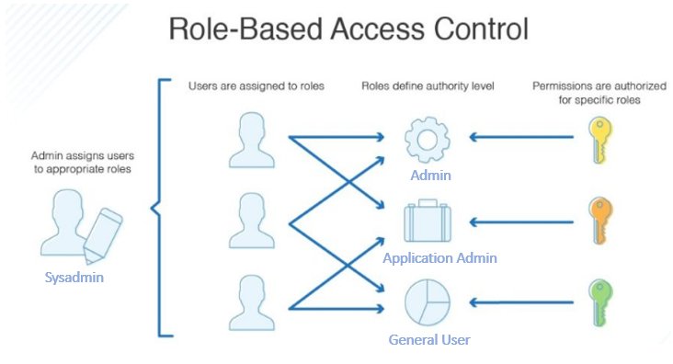

**User case Diagram:**

**Prerequisite:** One Sysadmin user and roles will be seeded in advance into the database as an installation\setup script.

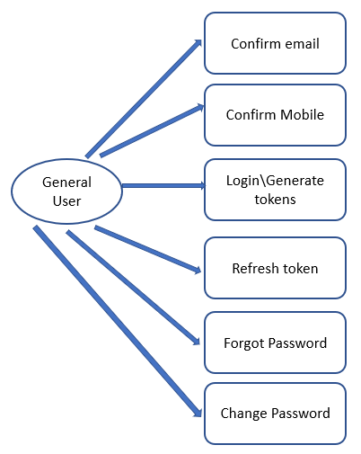

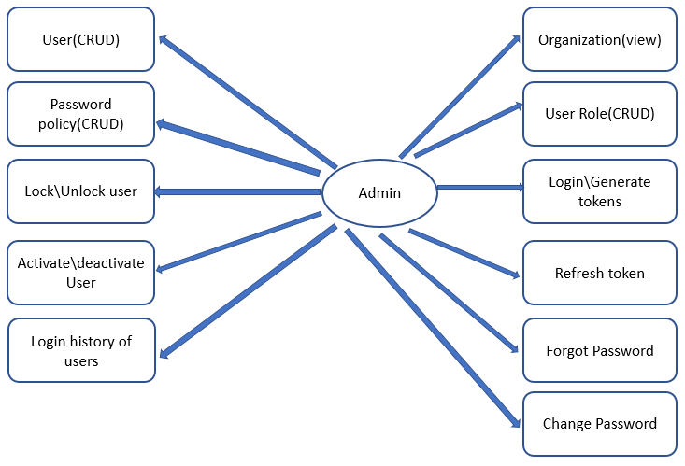

**Architecture Diagram:**

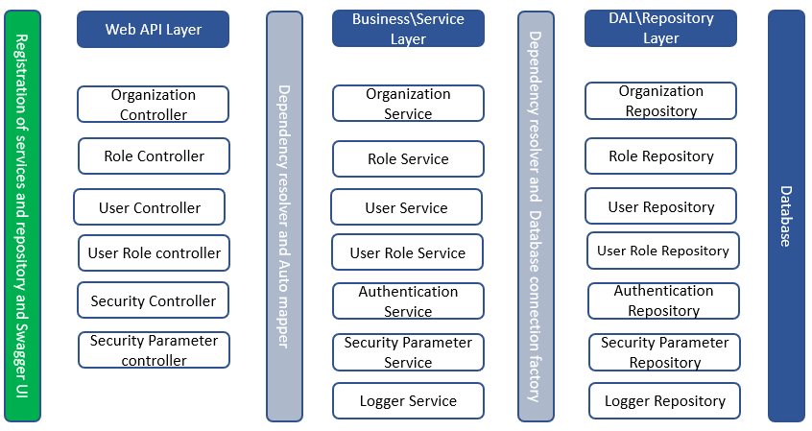

|  |  |  |  |  |  |  |
| --- | --- | --- | --- | --- | --- | --- |
| **Endpoint** | **Type** | **Sysadmin** | **Admin** | **Application Admin** | **General User** | **Anonymous User** |
| /api/Organization | GET all | **Badge Tick1 with solid fill** | **Badge Tick1 with solid fill** |  |  |  |
| /api/Organization/{id} | GET by Id | **Badge Tick1 with solid fill** | **Badge Tick1 with solid fill** |  |  |  |
| /api/Organization | POST | **Badge Tick1 with solid fill** |  |  |  |  |
| /api/Organization/{id} | PUT | **Badge Tick1 with solid fill** |  |  |  |  |
| /api/Organization/{id} | DELETE | **Badge Tick1 with solid fill** |  |  |  |  |
| /api/Role | GET all | **Badge Tick1 with solid fill** | **Badge Tick1 with solid fill** |  |  |  |
| /api/Role/{id} | GET by Id | **Badge Tick1 with solid fill** | **Badge Tick1 with solid fill** |  |  |  |
| /api/Role | POST | **Badge Tick1 with solid fill** |  |  |  |  |
| /api/Role/{id} | PUT | **Badge Tick1 with solid fill** |  |  |  |  |
| /api/Role/{id} | DELETE | **Badge Tick1 with solid fill** |  |  |  |  |
| /api/Security/token | POST |  |  |  |  | **Badge Tick1 with solid fill** |
| /api/Security/refreshToken | PUT | **Badge Tick1 with solid fill** | **Badge Tick1 with solid fill** | **Badge Tick1 with solid fill** | **Badge Tick1 with solid fill** |  |
| /api/Security/forgotPassword | POST |  |  |  |  | **Badge Tick1 with solid fill** |
| /api/Security/changePassword | POST | **Badge Tick1 with solid fill** | **Badge Tick1 with solid fill** | **Badge Tick1 with solid fill** | **Badge Tick1 with solid fill** |  |
| /api/Security/sendOtp | POST | **Badge Tick1 with solid fill** | **Badge Tick1 with solid fill** | **Badge Tick1 with solid fill** | **Badge Tick1 with solid fill** | **Badge Tick1 with solid fill** |
| /api/Security/validateOtp | POST | **Badge Tick1 with solid fill** | **Badge Tick1 with solid fill** | **Badge Tick1 with solid fill** | **Badge Tick1 with solid fill** | **Badge Tick1 with solid fill** |
| /api/Security/confirmMobile | POST | **Badge Tick1 with solid fill** | **Badge Tick1 with solid fill** | **Badge Tick1 with solid fill** | **Badge Tick1 with solid fill** |  |
| /api/Security/confirmEmail | POST | **Badge Tick1 with solid fill** | **Badge Tick1 with solid fill** | **Badge Tick1 with solid fill** | **Badge Tick1 with solid fill** |  |
| /api/Security/loginHistory | GET |  | **Badge Tick1 with solid fill** | **Badge Tick1 with solid fill** |  |  |
| /api/Security/lock | POST |  | **Badge Tick1 with solid fill** |  |  |  |
| /api/Security/unlock | POST |  | **Badge Tick1 with solid fill** |  |  |  |
| /api/SecurityParameter | GET all |  | **Badge Tick1 with solid fill** | **Badge Tick1 with solid fill** |  |  |
| /api/SecurityParameter/{id} | GET by Id |  | **Badge Tick1 with solid fill** | **Badge Tick1 with solid fill** |  |  |
| /api/SecurityParameter | POST |  | **Badge Tick1 with solid fill** |  |  |  |
| /api/SecurityParameter/{id} | PUT |  | **Badge Tick1 with solid fill** |  |  |  |
| /api/SecurityParameter/{id} | DELETE |  | **Badge Tick1 with solid fill** |  |  |  |
| /api/User | GET all |  | **Badge Tick1 with solid fill** | **Badge Tick1 with solid fill** |  |  |
| /api/user/{id} | GET by Id |  | **Badge Tick1 with solid fill** | **Badge Tick1 with solid fill** |  |  |
| /api/User | POST |  | **Badge Tick1 with solid fill** |  |  |  |
| /api/user/{id} | PUT |  | **Badge Tick1 with solid fill** |  |  |  |
| /api/user/{id} | DELETE |  | **Badge Tick1 with solid fill** |  |  |  |
| /api/user/activate | POST |  | **Badge Tick1 with solid fill** |  |  |  |
| /api/user/deactivate | POST |  | **Badge Tick1 with solid fill** |  |  |  |
| /api/UserRole | GET all |  | **Badge Tick1 with solid fill** | **Badge Tick1 with solid fill** |  |  |
| /api/UserRole/{id} | GET by Id |  | **Badge Tick1 with solid fill** | **Badge Tick1 with solid fill** |  |  |
| /api/UserRole | POST |  | **Badge Tick1 with solid fill** |  |  |  |
| /api/UserRole/{id} | DELETE |  | **Badge Tick1 with solid fill** |  |  |  |

**Future Scope/References:**

[**https://www.red-gate.com/simple-talk/dotnet/c-programming/policy-based-authorization-in-asp-net-core-a-deep-dive/**](https://www.red-gate.com/simple-talk/dotnet/c-programming/policy-based-authorization-in-asp-net-core-a-deep-dive/)

[**https://docs.microsoft.com/en-us/aspnet/core/security/authorization/roles?view=aspnetcore-5.0**](https://docs.microsoft.com/en-us/aspnet/core/security/authorization/roles?view=aspnetcore-5.0)